# **Task E**

## **Hypothetical Chart**

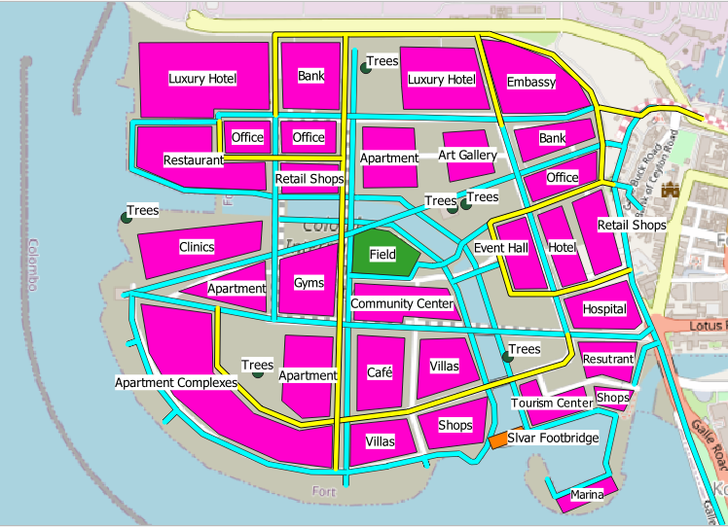

Figure 21

## **Comprehensive Chart**

 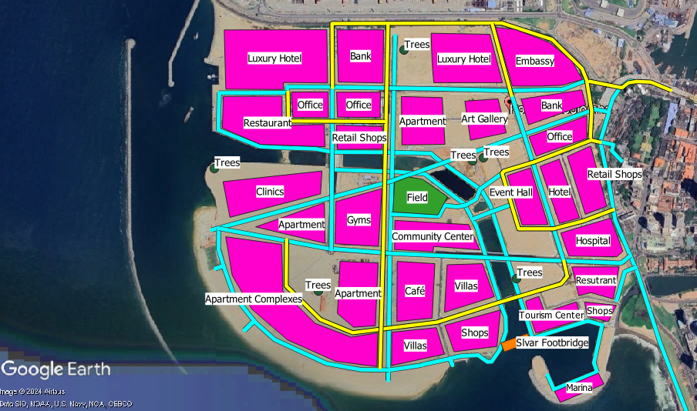

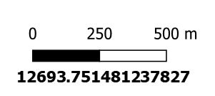 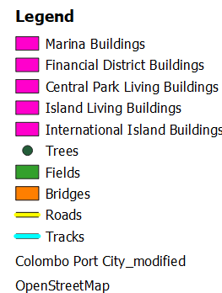

Figure 22

**Importance of Budgetary Efficiency:**

* Careful consideration of asset placement is required by the design of Port City to ensure its central role in Sri Lanka's economic strategy.

**Northern Area Development:**

* **Goal:** Establish a hub for premium services.
* **Inclusions:**
  + Executive suites for high-profile corporate activity.
  + Fine eating establishments to attract rich consumers.
  + Consular posts to promote international relations.
  + Workspaces to assist business activities.

**Central Area Focus:**

* **Goal:** Create a residential and cultural center.
* **Inclusions:**
  + Social resource centers to help the community.
  + Art sanctuaries to develop cultural appreciation.

**Northeast Sector Planning:**

* **Goal:** Develop a commercial zone.
* **Inclusions:**
  + Financial transactions are handled by treasury offices.
  + Function venues for both private and public events.
  + A health and wellness center that provides sanatorium services.

**Southeast Sector Vision:**

* **Goal:** Build a vibrant waterfront area.
* **Inclusions:**
  + Harbors at sea to facilitate marine trade.
  + Centers for exploration to captivate visitors.
  + Recreational places to promote leisure opportunities.

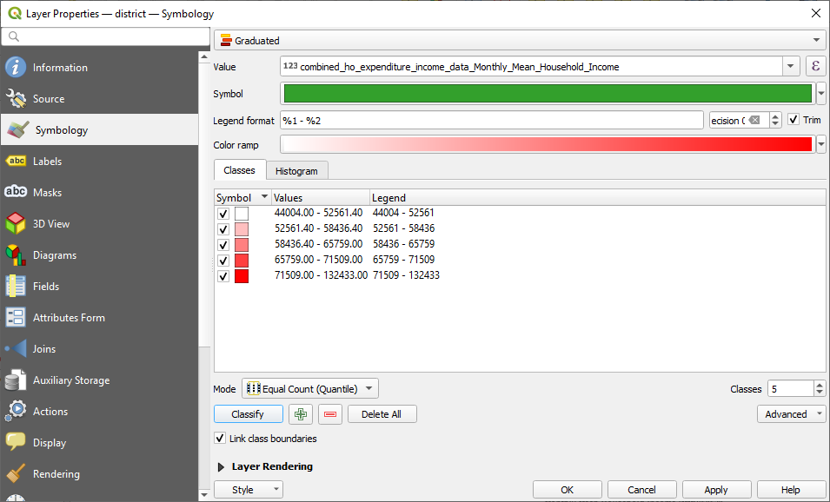

* Inscribe with inscriptions to improve textual clarity and facilitate maximal interpretive acuity.

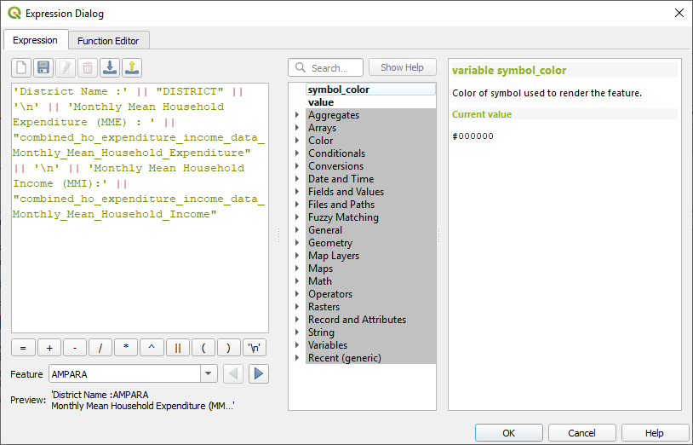

* Enshrined sophisticated partitioning subdivision diagram.

